Lesson 5 Teacher Reference

Spring scale and cart modifications and setup

Examine your 5-N push-pull spring scales. If these have a wire S hook on the end, bend the hook apart using two pliers until there is a large enough gap to slide the wire S hook out of the hole on each push-pull spring scale.  Save these S hooks as they will be needed for day 1 of this lesson when students will need to hook ends of two push-pull spring scales together for the pulling investigation they conduct. | 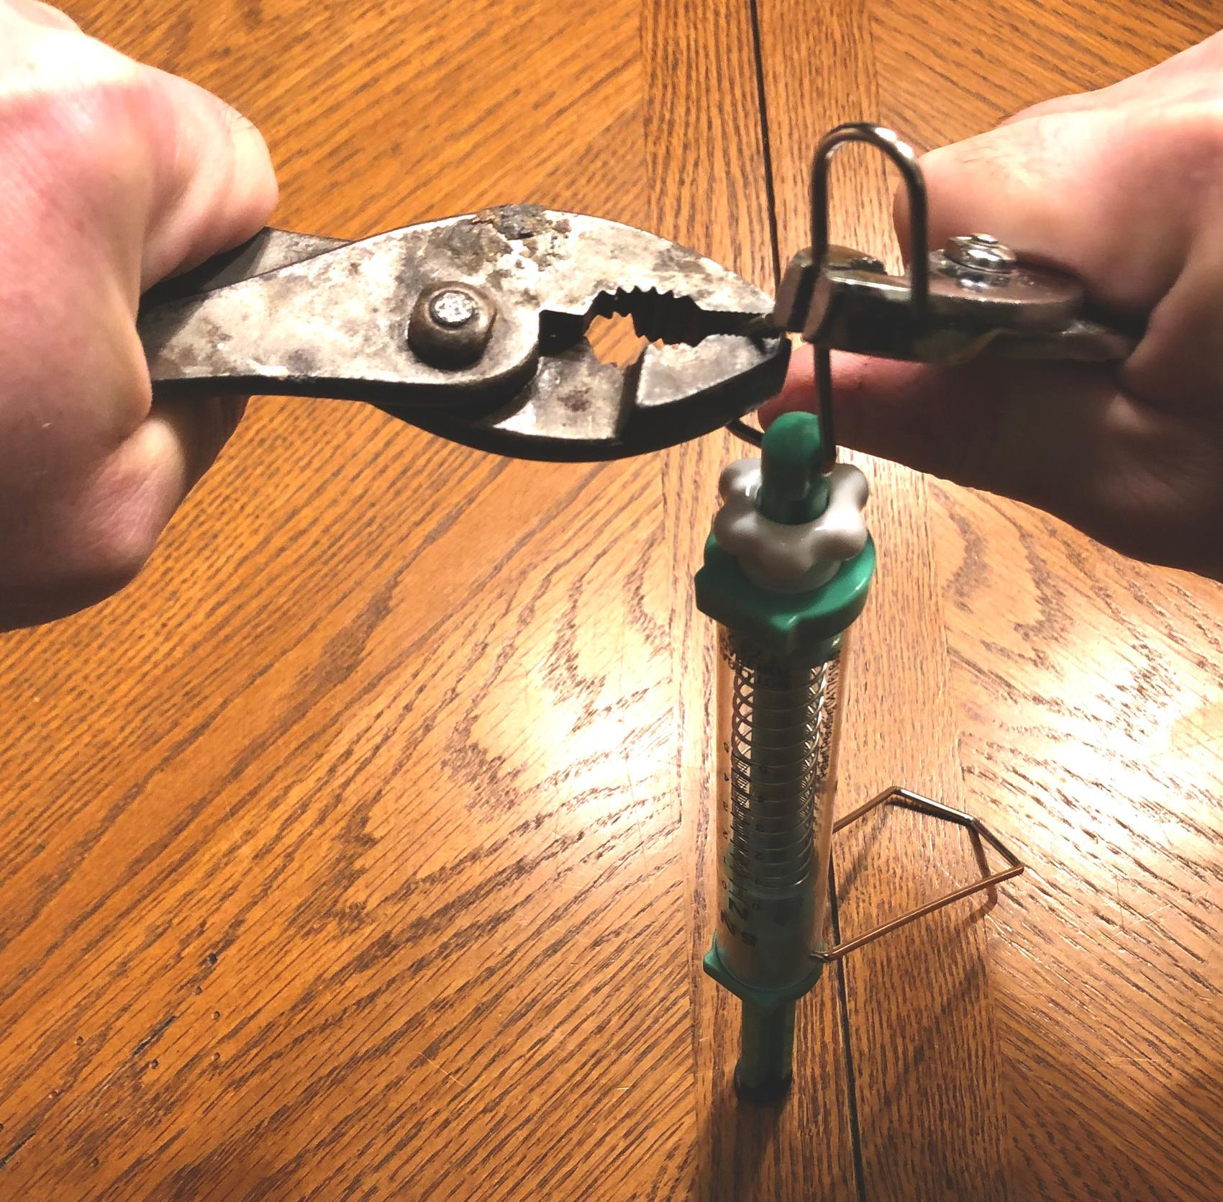
Use a twist-tie (or 2-inch piece of wire) and thread it through the hole. Then twist the two ends together. | 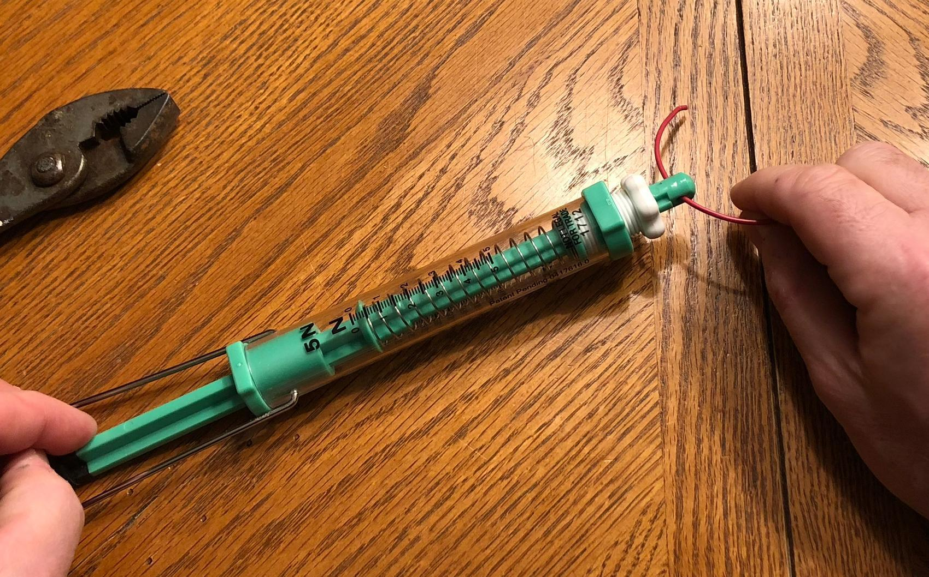
Zero each of your push-pull spring scales and keep checking this as you start to make markings on the plunger beam. Use a very fine-tip permanent marker and a ruler to mark graduations every 2 mm on the flat side of the push-pull spring scale plunger. | 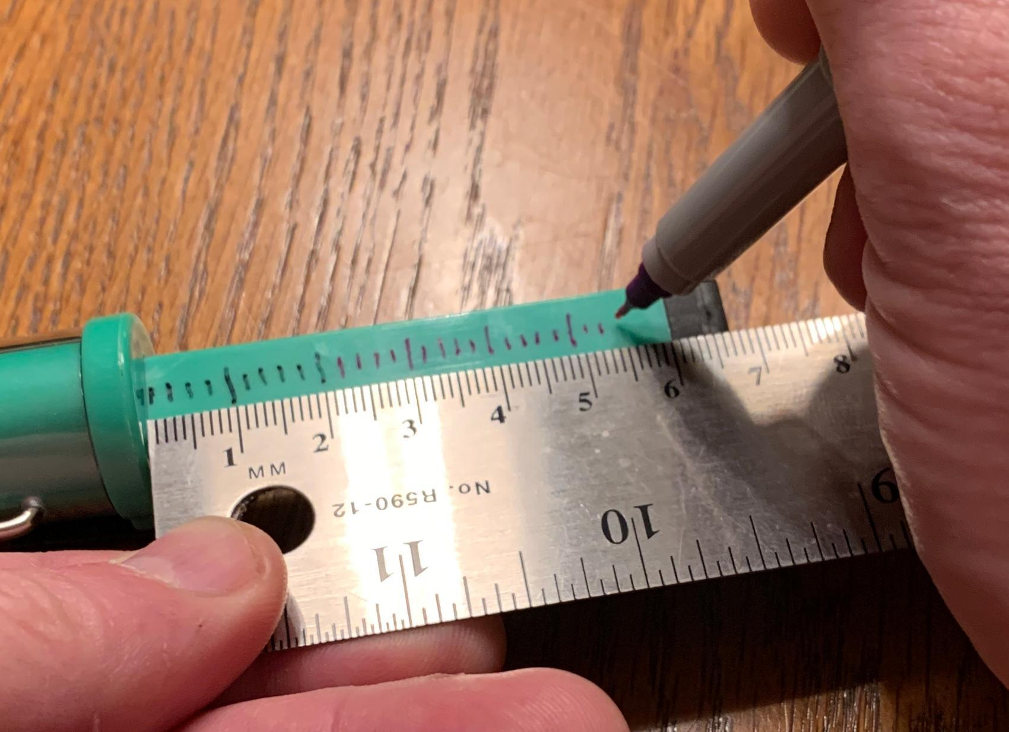
Do this for all your push-pull spring scales until you reach the end of the plunger beam. If you make a mistake you can wipe off the marking using rubbing alcohol and a paper towel. You will need to do this quickly before the ink has long to dry and let the surface dry before trying to re-mark them.
Cut two squares, ½” x ½” each, of hook and loop fasteners. Attach the fuzzy (loop) side on push-pull spring scales at the two locations shown. Attach the rough (hook) side to the cart at the same distance apart as the pieces you put on the spring scales. | 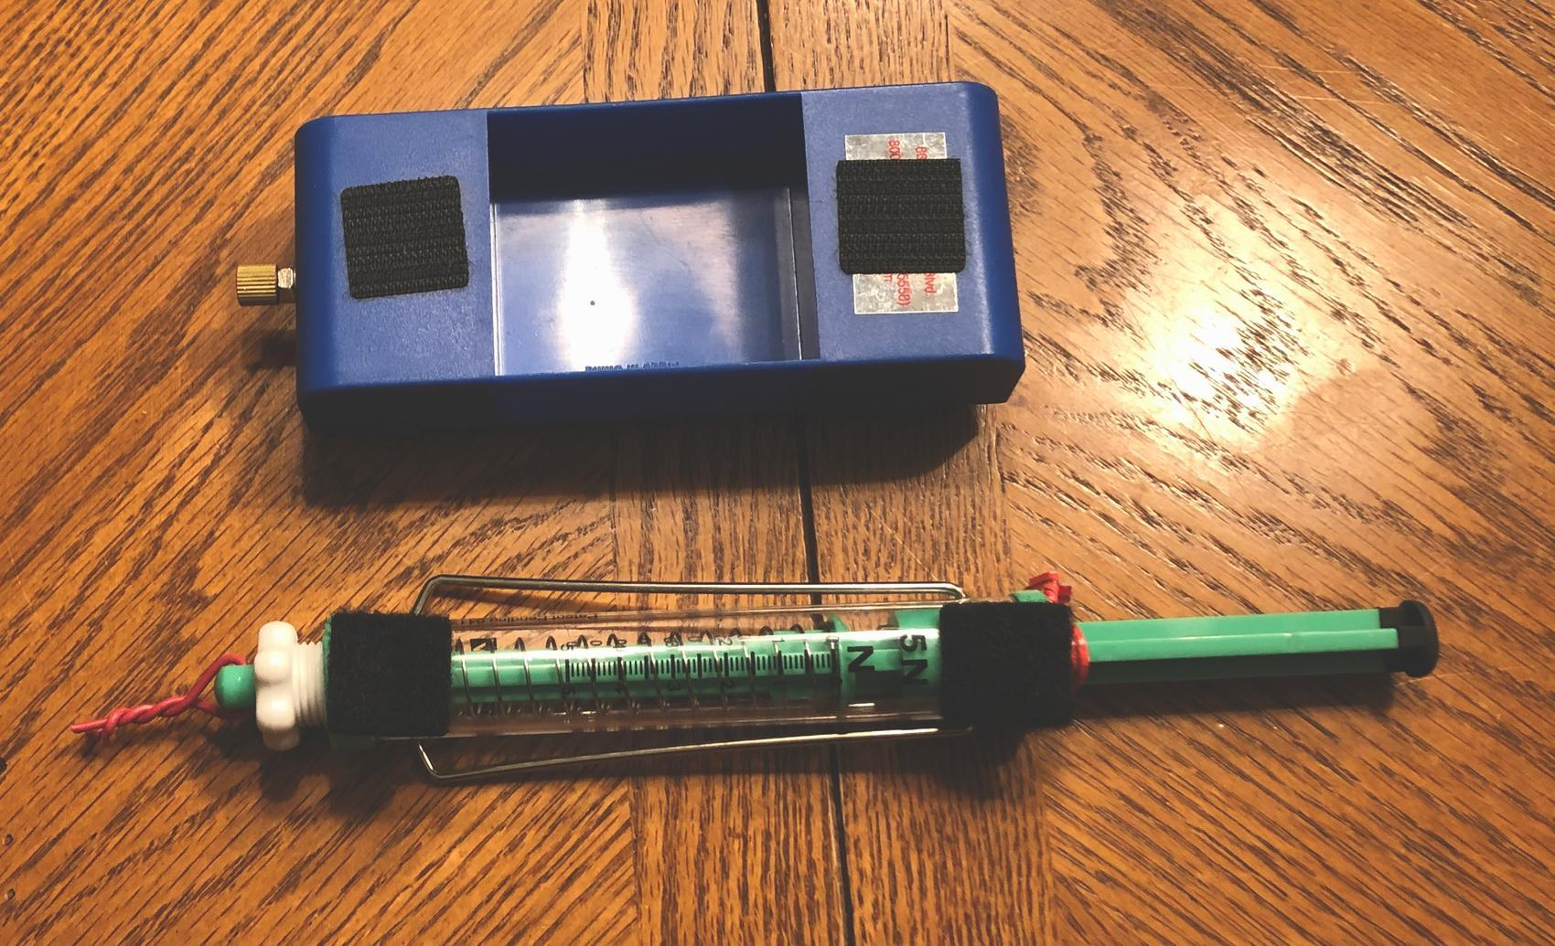
Attach the push-pull spring scales to the carts with the markings facing up. Twist a twist tie tightly over the plunger beam. It should be tight against the plunger but should slide back and forth on it easily. | 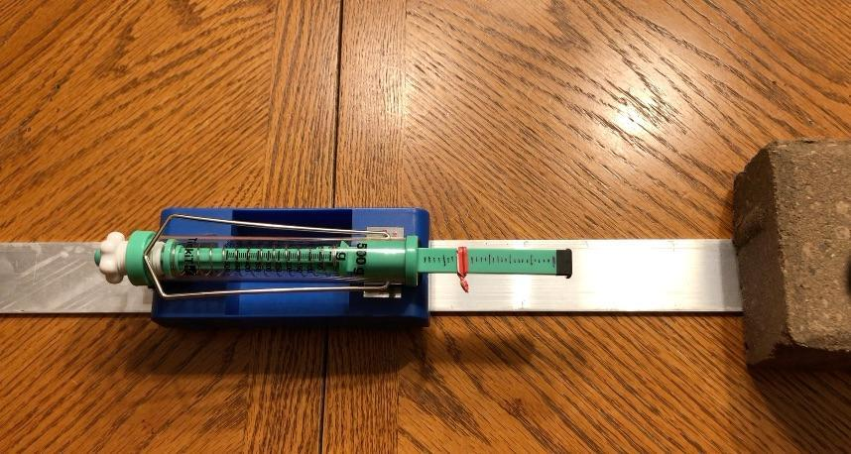
Build two of these carts for each station. Secure aluminum track to each testing station surface with painters tape. Leave 6 large washers and a small amount of modeling clay at each station.

